Ideation Phase
Brainstorm & Idea Prioritization Template

Date
Team ID
Project Name
Maximum Marks

Brainstorm & Idea Prioritization Template:
Brainstorming provides a free and open environment that encourages everyone within a team to participate in the creative thinking process that leads to problem solving. Prioritizing volume over value, out-of-the-box ideas are welcome and built upon, and all participants are encouraged to collaborate, helping each other develop a rich amount of creative solutions.Use this template in your own brainstorming sessions so your team can unleash their imagination and start shaping concepts even if you're not sitting in the same room.
Reference: https://www.mural.co/templates/brainstorm-and-idea-prioritization
Step-1: Team Gathering, Collaboration and Select the Problem Statement
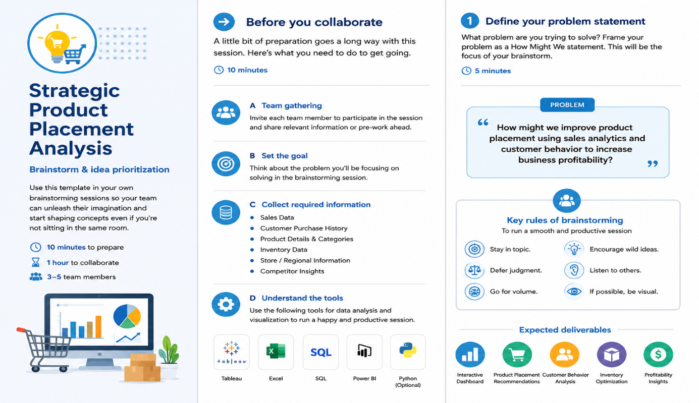
1.Team Gathing
The project team came together to discuss real-world challenges faced by retail businesses in product placement and sales performance. Each member shared ideas based on customer behavior, inventory management, and sales analysis
2. Collaboration
The team collaborated by sharing insights, analyzing sales data, and discussing customer purchasing patterns. Responsibilities were divided among members for data collection, analysis, dashboard design, and documentation.
3. Select the Problem Statement
Retail businesses often face difficulties in placing products effectively, leading to lower sales and reduced customer engagement. The project aims to analyze sales trends and customer buying behavior to recommend the best product placement strategies.

Step-2: Brainstorm, Idea Listing and Grouping
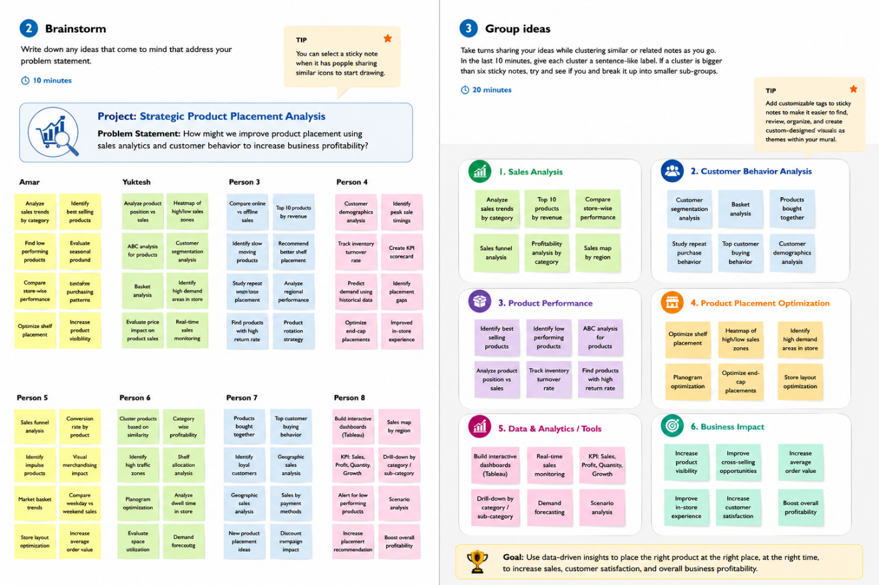

- Brainstorm
The team conducted a brainstorming session to generate ideas for improving product placement using sales and customer data. Different approaches such as sales trend analysis, customer behavior analysis, inventory optimization, and dashboard visualization were discussed. All ideas were considered to identify the most effective solution.
2. Idea Listing
The team listed key ideas including analyzing best-selling products, identifying low-performing products, studying customer purchasing patterns, comparing regional sales, and creating interactive Tableau dashboards.
3. Idea Grouping
The generated ideas were grouped into categories such as Sales Analysis, Customer Behavior Analysis, Product Performance, Inventory Management, and Data Visualization. Grouping the ideas helped the team organize tasks efficiently and focus on developing a comprehensive product placement strategy.

Step-3: Idea Prioritization
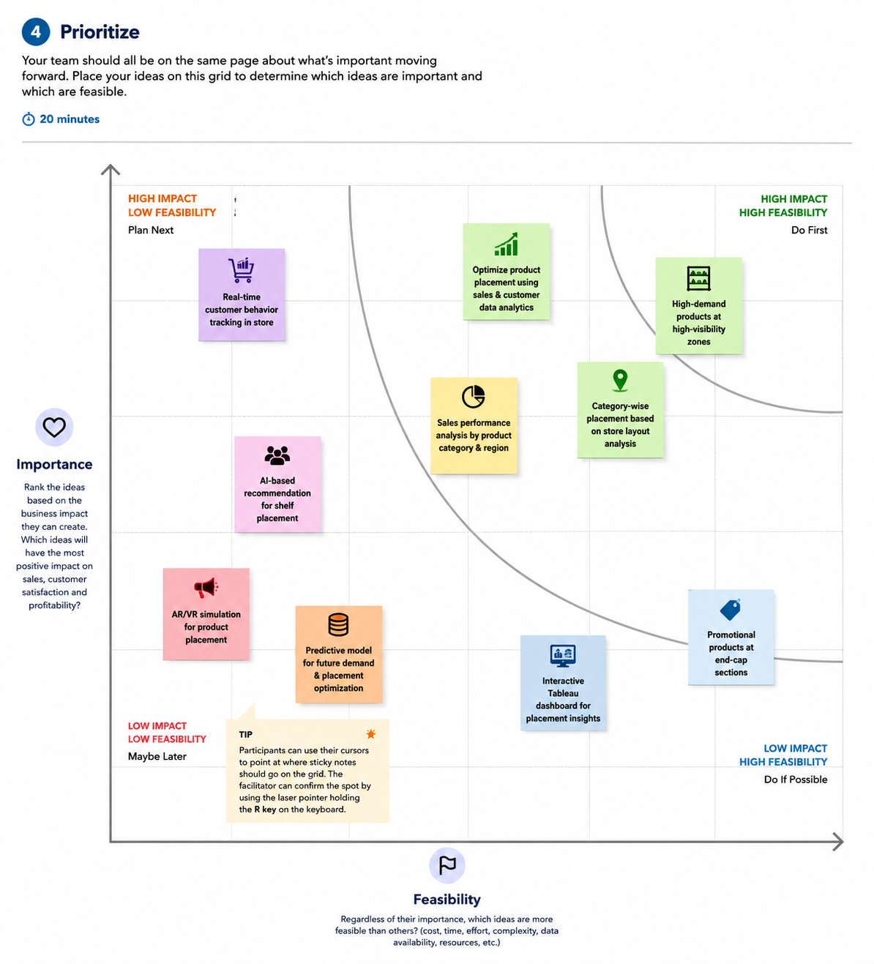

1. Idea Evaluation
The team evaluated all the brainstormed ideas based on business impact, feasibility, innovation, data availability, and implementation complexity. Each idea was carefully analyzed to determine its potential to improve product placement and increase sales.
2. Idea Prioritization
After evaluation, the team prioritized ideas that provide the highest business value. Sales analysis, customer behavior analysis, product performance analysis, and interactive dashboard development were identified as the top priorities
3. Final Selected Idea
The team finalized Strategic Product Placement Analysis as the project solution. The project focuses on analyzing sales trends, customer purchasing patterns, and product performance to recommend optimal product placement strategies

